In the “PyCitySchools.jpynb” report, an analysis was conducted on the data related to various schools, including their type, total number of students, total school budget, per student budget, average maths score, average reading score, percentage of students passing maths, percentage of students passing reading, and percentage of students passing both maths and reading (% overall passing).

The following are the key findings or conclusions from the analysis:

* Top Performing Schools (By % Overall Passing):

Based on the % overall passing metric, the top performing schools are those with the highest percentages of students passing both math and reading.These schools likely have effective teaching methods, supportive learning environments, and strong leadership contributing to their success. A screenshot of a computer

* Scores by School Spending:

Upon analysis, it appears that there is no clear connection between the total school budget or per student budget and academic performance. For example,

Bailey High School, which has one of the highest total budgets and per student budgets, does not have the highest overall passing percentage. Conversely, Holden High School has a relatively lower budget but boasts a high overall passing percentage.

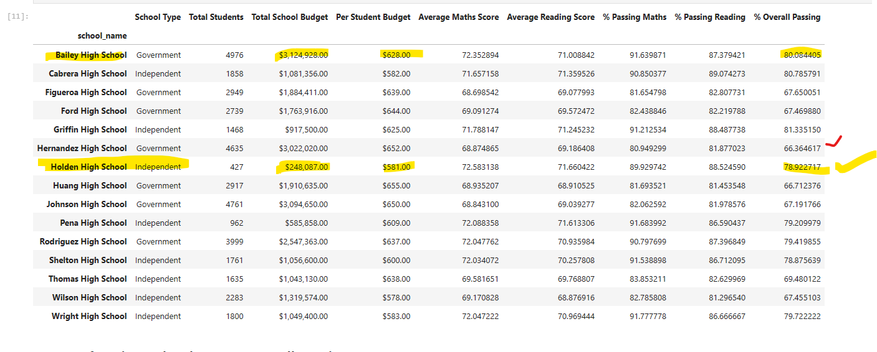

* Scores by School Size:

The analysis revealed that smaller schools tended to have higher average maths and reading scores, as well as higher percentages of students passing both subjects compared to larger schools.

* Scores by School Type:

Independent schools tend to have higher passing rates and overall passing percentages compared to Government schools.This could indicate differences in teaching staff allocation, teaching methodologies, or student demographics between the two types of schools.

